

PJT02513. R4C.SAP.FS.DLA.Customer_Enrollment.Alerts.CRM_ENH_DLA_003 | 



REVIEWER(S)
Name | Title | Department | Reviewed (date/time)
Manoj Ajgaonkar | SAP QA Advisor | SAP
Scott Tingle | AMI Program Lead | BTS
Jack Hobbick | Testing Program Manager | Business Integration Team
Amit Jadli | Testing Lead, Capgemini | Smart Energy Program
Jessica Scott | Audit Controls, Deloitte | Smart Energy Program
Clark Oeler | Audit Controls, Deloitte | Smart Energy Program
Chaitanya Kodela | Solution Architect | Smart Energy Program
Frank Lubis | CUST SUPPORT MGR | CE&O SCC-Lansing VCC

APPROVER(S)
Name | Title | Department | Approval (date/time)
Thomas Clark | DIV Program Mgr | Smart Energy Program
Elody Samuelson | DIV Program Mgr | Smart Energy Program
Zachary Pakkala | BUS SPRT CNSL II | Smart Energy Program
Loknath Sriparavastu | SAP lead, CMS Energy | Smart Energy Program
Ramesh Swarna | SAP Lead, Capgemini | Smart Energy Program
Tom Spring | BTS TECH | BTS SDM
Chad Conrad | BTS PROJECT MGR II | BTS SDM

CONTRIBUTORS
Name | Organization | Area of Contribution

VERSION HISTORY
Version | Date | Author(s) | Revision Notes
0.1 | 01/26/2015 | Abhishek Bansal | Initial version
0.2 | 02/16/2015 | Abhishek Bansal | Ready for Review/Approval
1.0 | 04/13/15 | Ed Abranovich | Approved Baseline Work Product

Table of Contents

REVIEWER(S) 2
APPROVER(S) 2
1 OBJECT REQUIREMENT SUMMARY 4
1.1 Object Information and Attributes 4
1.2 Requirements Summary and Business Driver 5
1.3 Assumptions 5
1.4 Current Functionality 6
1.5 Required Functionality 6
1.6 Project / Development Constraints 7
1.7 Performance Criteria 7
1.8 Other Objects Affected 7
1.9 External References 7
1.10 Definitions/Acronyms/Abbreviations 7
2 ENHANCEMENT DESIGN SPECIFICATIONS 9
2.1 Detail Requirements - Enhancement 9
2.2 Custom Class 10
2.3 Standard Rule 10
2.4 Custom Table Creation 10
2.5 Work Item Delivery Requirements 10
2.6 Triggering Events Determination 10
2.7 Escalation Requirements 10
2.8 Dependencies 10
2.9 Error Handling Method 10
2.10 Post Execution Notification Details 10
2.11 Process Log Details 10
2.12 Other 10
2.13 Unit Test Plan 11
2.14 Information Security 11
2.15 Audit 11
2.16 Questions / Issues / Risks 11

OBJECT REQUIREMENT SUMMARY

Object Information and Attributes

The following is current information about this object and document:
Object ID | CRM_ENH_DLA_003
Title | PJT02513.CBR4C.FS.DLA.Customer_Enrollment.Alerts.CRM_ENH_DLA_003
Team Which Owns the Object | DLA SAP team
System Version | CRM 7.0
Development Type | Enhancement
Priority | High
Estimated Complexity | Medium
Link to Process Flow | Refer to System BPD for DLA Customer Enrollment: http://teams/sites/PMO%20Team/SGE/SGE%20Documents/Release%204%20Complex%20Billing/Release%20R4c/08%20Work%20In%20Progress/Define/System%20Business%20Process%20Design/DLA%20Switch/PJT02513%20R4c%20SAP%20SBPD%20DLA%20Customer%20Enrollment%20and%20Work%20Management.docx

Requirements Summary and Business Driver

The Direct Load Administration (DLA) program is to provide a method of demand-side grid load shedding by means of one or more on/off switches installed on the load side of a customer’s premise, between an air conditioning unit(s) and the AMI meter. These switches can then be remotely activated by Consumer’s to control A/C load shedding, as per the customer’s contractual agreement and the need for a particular grid load-shedding event.

During or outside of a load-shedding event if customers call into the Consumers Energy, the CE CSRs need to be alerted that the customer is enrolled into the DLA program. The alerts will be displayed throughout the lifecycle of DLA enrollment, in addition to the Data Environment indicators, or Interaction Records, logged for DLA-related account changes.

The following gap from the DLA System Business Process document is addressed in this specification.
Ref. | PRICEFW ID | Enhancement Description
DDCE-087 | CRM_ENH_DLA_003 | IC alerts will be displayed to the CSR, through the DLA enrollment lifecycle. Accordingly, two alerts will be added:  - DLA Enrollment pending  - DLA Enrollment active

Alternatives to Object
The CE CSRs will have to find the relevant information via Interaction Record history.

Impact of Implementation
By implementing the proposed automation, the CSR will have additional visibility into the DLA enrollment process, covering “pending” and “enrolled” statuses.

Impact of No Implementation
Reduced visibility of DLA enrollment, especially during the pending stage.

Assumptions

- DIV communicates pending and completed customer enrollments discretely.
- The alerts are valid for the Enrollment period only. Alerts for de-enrollment are not required.

Current Functionality

There is current functionality to display IC Alerts for non-DLA events only at this point. DLA relevant alerts will be introduced with the Smart Energy Release R4C.

Required Functionality

DLA enrollment can take place in two different scenarios.

Enrollment with Switch Install – Upon enrollment into the DLA program accompanied by the installation of DLA Switch, the enrollment process occurs in two steps.

The first step is recorded with the enrollment initiation message sent by the DIV. The message confirms an initial acceptance of the customer, to participate in this program, that necessitates the installation of the switch. Until a switch is installed, the enrollment is treated as “Pending”. During this period, for the Call Center users, an alert is to be displayed for the respective customer account, that says: “PROGRAM NAME Enrollment Pending”. A mock-up of this alert, as below:

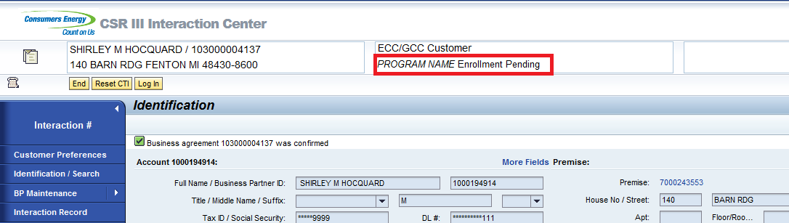

The second step is recorded, once the switch installation is completed by the DIV. Upon successful switch activation, a second confirmation message is sent by the DIV, that indicates that the enrollment is “Completed”. This point onwards, for the Call Center users, an alert is to be displayed for the customer account that states: “PROGRAM NAME Program Participant”. A mock-up of the alert, as below:
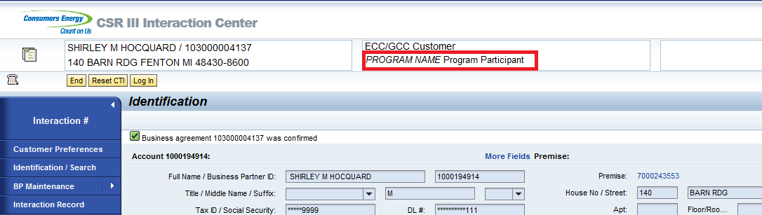

Enrollment without Switch Install – Upon enrollment into the DLA program not accompanied by the installation of DLA Switch, the process is completed in a single step. Since, a switch is pre-intsalled, DIV sends a confirmation message to mark Customer enrollment and switch activation.
This point onwards, for the Call Center users, an alert is to be displayed for the customer account that states: “PROGRAM NAME Program Participant”.

Note: The text PROGRAM NAME is used as a placeholder here. Once a name is official for the DLA program, it will be used to update the Alert text.

Interaction Center Webclient, is accessed via multiple Business Roles, and the changes will be effective for all of the following roles:

Role Name | Role Description
ZCRM7_BRC | CSR III B. Role - BRC Switch
ZCRM7_PRM | CSR III B. Role - PRM Switch
ZCRM7_TEAM | CRM 7.0 Functional Team Role
ZIC_BCOP | Business Ctr Bus. Role (7)
ZIC_BKOF | Customer Billing Bus. Role (4)
ZIC_CSR1 | CSR I Business Role (1)
ZIC_CSR2 | CSR II Business Role (2)
ZIC_CSR3 | CSR III Business Role (3)
ZIC_CSRX | Outsource CSR Business Role-10
ZIC_EAM | EAM Business Role (6)
ZIC_TRAINING | Training Dept Bus. Role (0)
ZIC_VCC | VCC Mgmt Bus. Role (9)
ZIC_RVRC | Revenue Recovery Bus. Role (5)
ZIC_CLNT | Client Services Bus. Role (8)

Project / Development Constraints
None Identified.

Performance Criteria

The introduction of a additional alerts is expected to least impact the current system performance. It is understood, that introduction of additional alerts, leads to additional data gathering, every time an account is confirmed. The changes will be designed in a way, that no additional calls to the backend system are required, hence minimizing the processing overhead introduced with the new alerts.

Other Objects Affected
None Identified.

External References
None Identified.

Definitions/Acronyms/Abbreviations

DIV | Device Installation Vendor
SAP | Systems, Applications & Products in Data Processing
DLA | Direct Load Adminstration
CRM | Customer Relationship Management SAP system
CE | Consumers Energy
CSR | Customer Service Representative
WO | Work Order
Service Delivery Point ID | SAP Device Location
DPP | Dynamic Peak Pricing
CSDD | Customer Select Due Date
IC | Interaction Center

ENHANCEMENT DESIGN SPECIFICATIONS

Detail Requirements - Enhancement

Enhancement Requirements
Number | Description of Requirement
1 | Create a Z-Class ZCL_CRM_IC_F_G_DLA: Use CL_CRM_IC_F_G_BA as SuperClass.
2 | Implement Interface method IF_CRM_SMF_SERVICE~EXECUTE, to process/return the following ICRULE attributes:  - ZDLA_PENDING  - ZDLA_COMPLETED
3 | ZDLA_PENDING is set to “X” if:  DLA_Enrollment_Pending Interaction Record with Reason Code “ZDLC” exists  AND DLA_Enrollment_Complete Interaction Record with Reason Code “ZDLD” does not exist).  The above check is performed for the confirmed BA, for Interaction Records (run query BTQ1Order or similar for selection criteria PROCESS_TYPE = Z010, BU_PARTNER) filtered by BA.
4 | ZDLA_COMPLETED is set to “X” if:  DLA_Enrollment_Pending Interaction Record with Reason Code “ZDLD” exists  AND DLA_Enrollment_Complete Interaction Record with Reason Code “ZDLE” does not exist).  The above check is performed for the confirmed BA, for Interaction Records (run query BTQ1Order or similar for selection criteria PROCESS_TYPE = Z010, BU_PARTNER) filtered by BA.
5 | The Alerts are triggered for the following IC Events: BuAgConfirmed. The event is defined within the Rule Policy ZDLA_ALERTS.

Description: Describe each activity mentioned in the process flow diagram.
Detailed Description of Activities
Activity 1 –

Activity 2 –

Activity 3 –

Custom Class
ZCL_CRM_IC_F_G_DLA

Standard Rule
None Identified.

Custom Table Creation
None Identified.

Work Item Delivery Requirements
None Identified.

Triggering Events Determination
BUAGConfirmed.

Escalation Requirements
None Identified.

Dependencies
Customer Enrollment Interaction Records enhancements, delivered with functional specification, “PJT02513.CBR4C.FS.DLA.Customer_Enrollment.Interaction_Records.CRM_ENH_DLA_002”.

Error Handling Method
None Identified.

Post Execution Notification Details
None Identified.

Process Log Details
None Identified.

Other
None Identified.

Unit Test Plan

The following scenarios need to be tested.
Unit test Step No | Test Condition | Expected Result | Actual Result
1 | Account Confirmed in IC, when the Enrollment is in Pending status. | Alert “PROGRAM NAME Enrollment Pending” is displayed.
2 | Account Confirmed in IC, when the Enrollment is in Completed status. | Alert “PROGRAM NAME Program Participant” is displayed.
3 | Account Confirmed in IC, when the De-enrollment is Completed. | No Alert is displayed.

Information Security
None Identified.

Information Classification
None Identified.

Security Roles (Profiles and Authorizations)
None Identified.

Table Security (if applicable)
None Identified.

ABAP Program Security (if applicable)
None Identified.

Audit
None Identified.

Questions / Issues / Risks
None Identified.

